1.Microservices – JWT
Question 1: Implement JWT Authentication in ASP.NET Core Web API
Aim
To implement JWT (JSON Web Token) Authentication in an ASP.NET Core Web API and secure API endpoints using the [Authorize] attribute.
Objective
In this lab, I implemented JWT-based authentication in an ASP.NET Core Web API.
The main tasks performed were:
- Created an ASP.NET Core Web API project using Visual Studio.
- Configured the project using .NET 8.
- Installed the Microsoft.AspNetCore.Authentication.JwtBearer NuGet package compatible with .NET 8.
- Created a login model.
- Created a login API endpoint.
- Validated username and password.
- Generated a JWT token after successful login.
- Configured JWT authentication and token validation.
- Added authorization to the application.
- Created a protected API endpoint using [Authorize].
- Configured Swagger to support JWT Bearer authentication.
- Tested the API using Swagger UI.
- Verified successful and unsuccessful authentication scenarios.
Project Creation
I created a new ASP.NET Core Web API project in Visual Studio.
Project Name
JWTWebAPI
Framework
.NET 8.0
Authentication
None
JWT authentication was manually implemented in the application.
NuGet Package Installation
The following NuGet package was installed:
Microsoft.AspNetCore.Authentication.JwtBearer
Since the project uses .NET 8, an 8.x version of the package was used.
This package provides support for validating JWT Bearer tokens in ASP.NET Core applications.
JWT Configuration
The JWT configuration was added to appsettings.json.
The configuration contains:
- Secret key
- Issuer
- Audience
- Token duration
Complete Code
appsettings.json
{
"Jwt": {
"Key": "ThisIsASecretKeyForJwtToken123456789",
"Issuer": "MyAuthServer",
"Audience": "MyApiUsers",
"DurationInMinutes": 60
},
"Logging": {
"LogLevel": {
"Default": "Information",
"Microsoft.AspNetCore": "Warning"
}
},
"AllowedHosts": "*"
}
Login Model
Models/LoginModel.cs
namespace JWTWebAPI.Models
{
public class LoginModel
{
public string Username { get; set; }

public string Password { get; set; }
}
}
Program.cs
The JWT authentication and authorization services were configured in Program.cs.
Complete Code
using Microsoft.AspNetCore.Authentication.JwtBearer;
using Microsoft.IdentityModel.Tokens;
using Microsoft.OpenApi.Models;
using System.Text;

var builder = WebApplication.CreateBuilder(args);

// Add Controllers
builder.Services.AddControllers();

// JWT Authentication
builder.Services.AddAuthentication("Bearer")
.AddJwtBearer("Bearer", options =>
{
options.TokenValidationParameters = new TokenValidationParameters
{
ValidateIssuer = true,
ValidateAudience = true,
ValidateLifetime = true,
ValidateIssuerSigningKey = true,

ValidIssuer = builder.Configuration["Jwt:Issuer"],
ValidAudience = builder.Configuration["Jwt:Audience"],

IssuerSigningKey = new SymmetricSecurityKey(
Encoding.UTF8.GetBytes(
builder.Configuration["Jwt:Key"]!
)
)
};
});

// Authorization
builder.Services.AddAuthorization();

// Swagger Configuration
builder.Services.AddEndpointsApiExplorer();

builder.Services.AddSwaggerGen(options =>
{
// Define Bearer JWT Authentication
options.AddSecurityDefinition("Bearer", new OpenApiSecurityScheme
{
Name = "Authorization",
Type = SecuritySchemeType.Http,
Scheme = "Bearer",
BearerFormat = "JWT",
In = ParameterLocation.Header,
Description = "Enter your JWT token in the format: Bearer {your token}"
});

// Apply JWT Authentication to Swagger
options.AddSecurityRequirement(new OpenApiSecurityRequirement
{
{
new OpenApiSecurityScheme
{
Reference = new OpenApiReference
{
Type = ReferenceType.SecurityScheme,
Id = "Bearer"
}
},
Array.Empty<string>()
}
});
});

var app = builder.Build();

// Enable Swagger
if (app.Environment.IsDevelopment())
{
app.UseSwagger();
app.UseSwaggerUI();
}

app.UseHttpsRedirection();

// Authentication must come before Authorization
app.UseAuthentication();

app.UseAuthorization();

app.MapControllers();

app.Run();
AuthController
The AuthController is responsible for handling user login and generating the JWT token.
Controllers/AuthController.cs
using Microsoft.AspNetCore.Mvc;
using Microsoft.IdentityModel.Tokens;
using System.IdentityModel.Tokens.Jwt;
using System.Security.Claims;
using System.Text;
using JWTWebAPI.Models;

namespace JWTWebAPI.Controllers
{
[ApiController]
[Route("api/[controller]")]
public class AuthController : ControllerBase
{
private readonly IConfiguration _configuration;

public AuthController(IConfiguration configuration)
{
_configuration = configuration;
}

[HttpPost("login")]
public IActionResult Login([FromBody] LoginModel model)
{
// Simple hardcoded user for demonstration
if (model.Username == "admin" &&
model.Password == "admin123")
{
var token = GenerateJwtToken(model.Username);

return Ok(new
{
Token = token
});
}

return Unauthorized(new
{
Message = "Invalid username or password"
});
}

private string GenerateJwtToken(string username)
{
var claims = new[]
{
new Claim(ClaimTypes.Name, username)
};

var key = new SymmetricSecurityKey(
Encoding.UTF8.GetBytes(
_configuration["Jwt:Key"]!
)
);

var credentials = new SigningCredentials(
key,
SecurityAlgorithms.HmacSha256
);

var token = new JwtSecurityToken(
issuer: _configuration["Jwt:Issuer"],
audience: _configuration["Jwt:Audience"],
claims: claims,
expires: DateTime.UtcNow.AddMinutes(
Convert.ToDouble(
_configuration["Jwt:DurationInMinutes"]
)
),
signingCredentials: credentials
);

return new JwtSecurityTokenHandler()
.WriteToken(token);
}
}
}
SecureController
The SecureController contains a protected endpoint.
The [Authorize] attribute ensures that only users with a valid JWT token can access the endpoint.
Controllers/SecureController.cs
using Microsoft.AspNetCore.Authorization;
using Microsoft.AspNetCore.Mvc;

namespace JWTWebAPI.Controllers
{
[ApiController]
[Route("api/[controller]")]
[Authorize]
public class SecureController : ControllerBase
{
[HttpGet]
public IActionResult GetSecureData()
{
return Ok(new
{
Message = "You have successfully accessed the protected endpoint!",
User = User.Identity?.Name
});
}
}
}
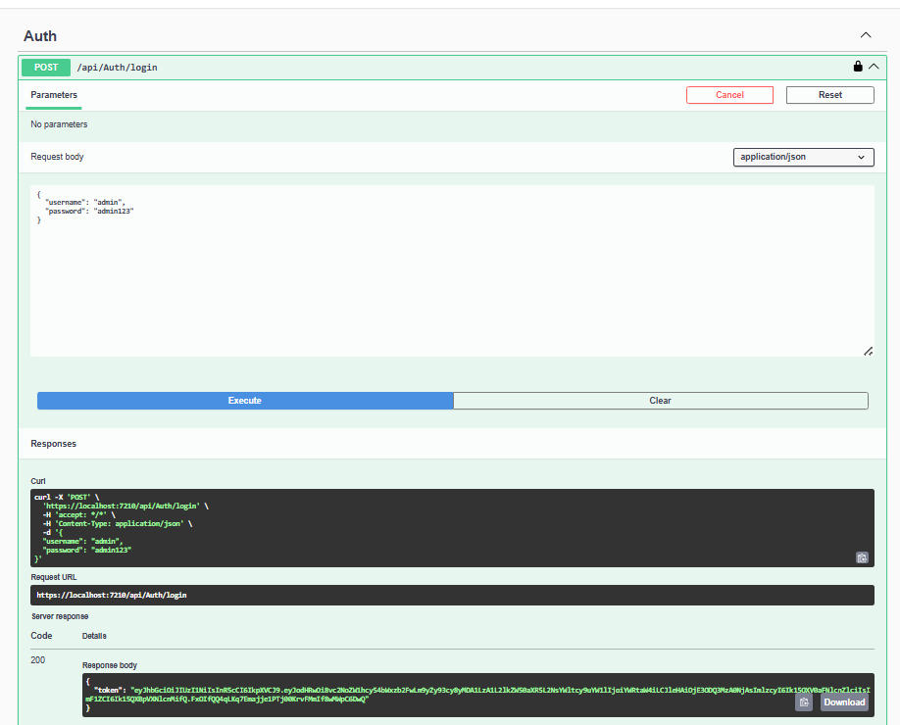
Output

